
∑.E.M.
Releases notes v1.03

Releases notes
v1.03
Composant update 3
Bugs 3
Features 3
.csv file import line quote 3
Task declaration page 4
Manufacturing information for quote & order line 4
Change color of head document 5
Change page users view 5
Activate or desactivate an company 6
Define default unit 6
Define default VAT 7
Margin / Total time info on task page 7

Composant update
- #126 Bump dompdf/dompdf from 2.0.1 to 2.0.2
- #128 Bump dompdf/dompdf from 2.0.2 to 2.0.3
- #119 Bump json5 from 1.0.1 to 1.0.2
- #167 Bump symfony/http-kernel from 6.2.5 to 6.2.6

Bugs
- #124 Tash manage, component id not validate
- #120 Division by zerro from margin calculation
- #120 Estimated budget not working after change year
- #109 Wrong rediction on notification
- #122 Break Down not update statu task on order line

Features

.csv file import line quote
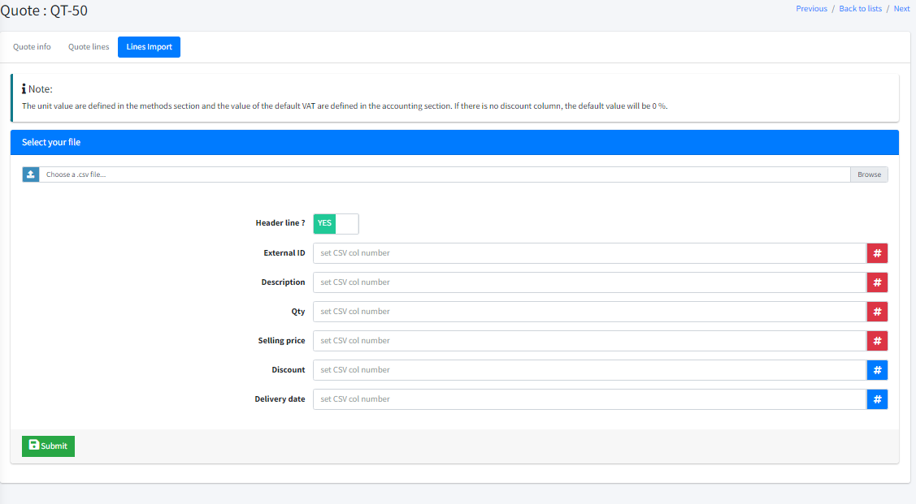

Task declaration page
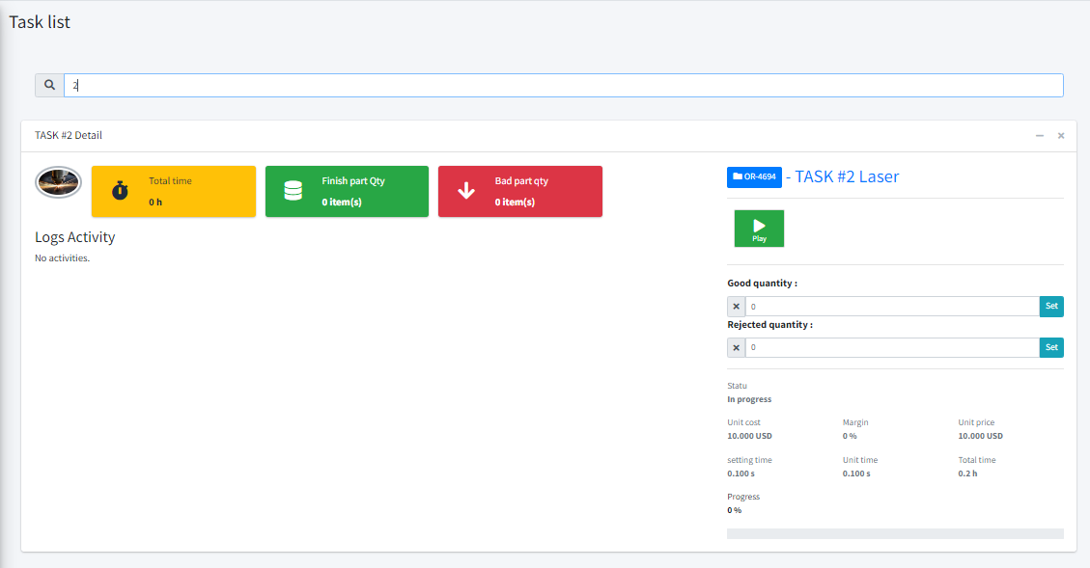

Manufacturing information for quote & order line

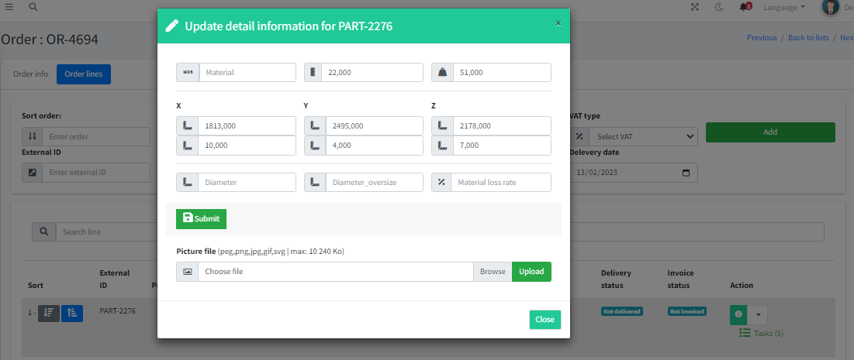

Change color of head document

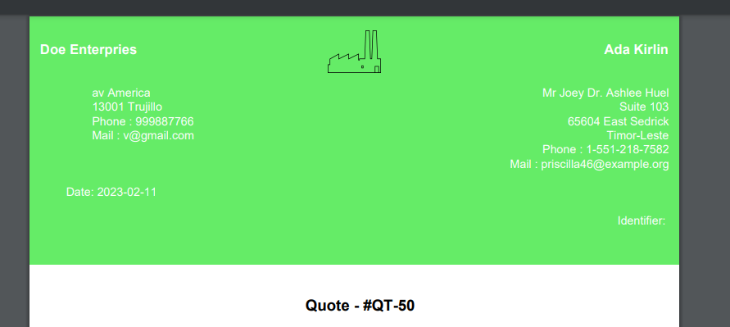

Change page users view

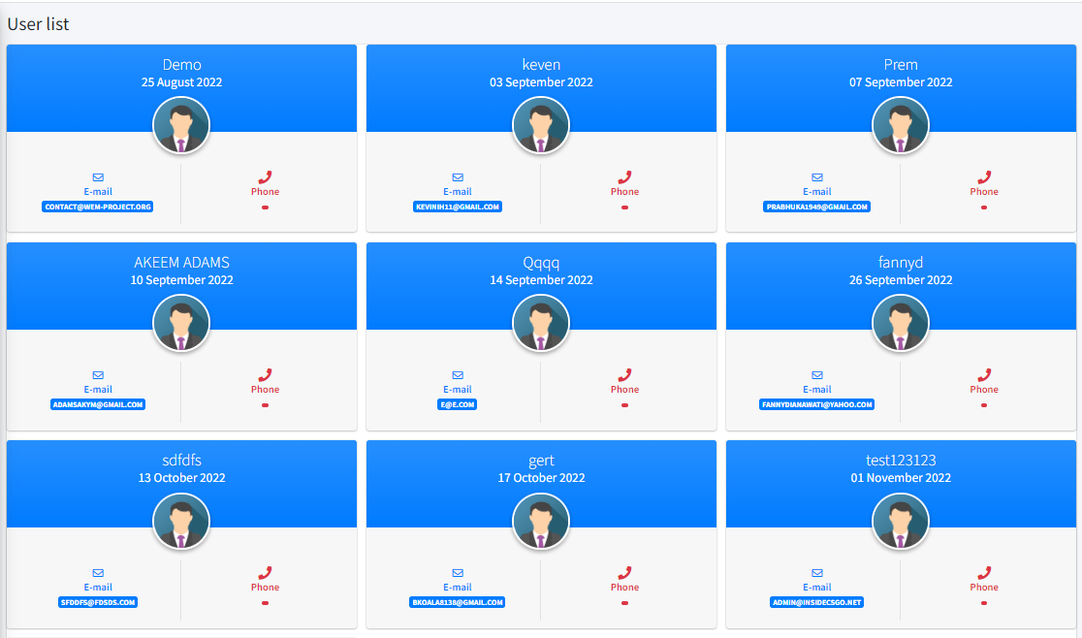

Activate or desactivate an company

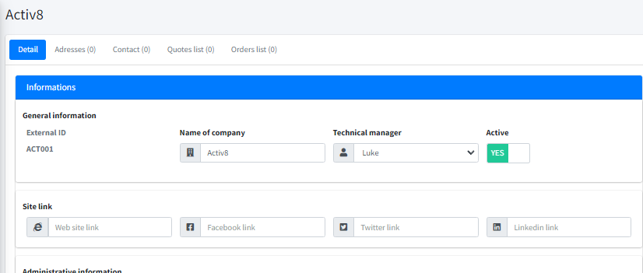

Define default unit

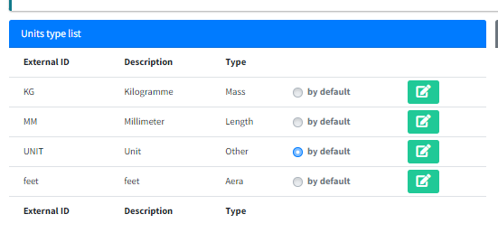

Define default VAT
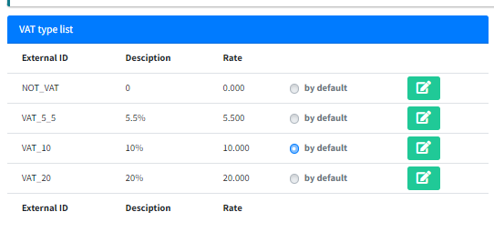

Margin / Total time info on task page

